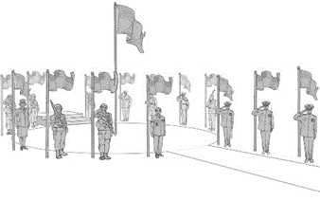
Colerain Veterans Memorial T-Shirt Sheet

If you would like to help the Colerain Veterans Memorial, you can sponsor our t-shirts or order some!

Please circle below whether you would like to sponsor or order:

I would like to sponsor:
Your company name and phone number will appear on 100 of the t-shirts for $100.
Company Name: _____________________________________________________
Contact Name: _____________________________________________________
Phone Number: _____________________________________________________

  - I would like to order:
Small/Medium/Large are $20 | 2x/3x/4x are $25 | Girls V-Neck is $25
Quantity: ______________________
Size(s): ______________________
FRONT

BACK

MAIL THIS FORM: Colerain Veterans Memorial P.O. Box 532196 Cincinnati Ohio 45252
